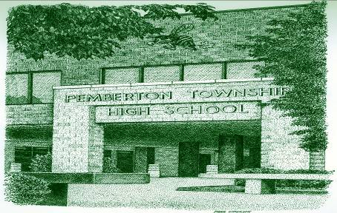
Pemberton Township High School
148 Arney’s Mount Rd.
Pemberton, NJ 08068
Phone: (609) 893-8141 ext. 1800
July 29, 2026

Business Name
Street Address 1
Street Addres 2
City, State Zip Code

Dear Business Name,

It is that time of year again, the Pemberton Players of Pemberton Twp High School are preparing for another musical production. This year our students will be presenting the musical The Addams Family. Once again, with the rousing success of last year’s production we have our work cut out for us to top that success. Auditions have taken place, the show has been cast and our students are eagerly preparing to perform our show in February.
As always we count on the generosity of local businesses and individuals for donations (of any kind) to help keep our program running. If you have purchased an ad in our program booklet in the past, we hope that you will consider purchasing an ad again. Enclosed is an order form that you may fill out and include with the ad you would like published.
If you would like to donate towards our concession stand, or if you have been asked to donate prop or scenery items, please check the box indicating “Donation” otherwise check box next to the appropriate ad, enclose the associated fee and return it to us to the address above with your ad to be printed. Please note that if you do donate towards our concession stand (or any other aspect of our production) you will be granted a full-page ad in our program at no additional cost to you (that is a $100 value). If you wish us to design an ad for you please let us know as well. Thank you for your continued support and we hope to hear from you soon.
Sincerely,
Christian Jewell
Christian Jewell
Play Business Manager
Pemberton Twp High School
cjewell@pemb.org
Phone: 609-893-8141 ext 2910

